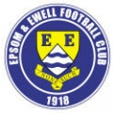 | Epsom & Ewell F.C.  4  v  Frimley Green  Saturday, 13th September 2014
For our League match this afternoon we welcome the players, officials and supporters of Frimley Green, along with today's match officials and of course our own regular supporters.

I’m sure that many of you will be aware that today is to be Lyndon Buckwell’s last game in charge as Manager of our club. It is his 407th game, and when you add the 100 he also made as a player it shows how many years of service he has provided for our club. We have plenty more about Lyndon within these pages and hopefully we can give him a good send off today.

Today’s opponents might choose to disagree with that sentiment! They were unfortunate to catch us on fairly good form twice last season as we recorded a 3-0 win here and a 5-1 win at the Recreation Ground. However, I recall that the home win was not decided until we scored a couple of late goals and following our uncertain League start we can take no result for granted right now.

Following our 1-1 draw at home to Croydon in the F.A. Cup we met with a disappointing defeat in the replay, losing 4-1 at the Arena. In both games we took the lead, yet were unable to see the match out, which tells you that our players are good enough, but maybe just lacking a little in terms of experience.

Our team against Croydon was very young and when Sam Robinson replaced Ben Hayward it got slightly younger still, averaging just 21 years and 318 days. Now I don’t have every past players date of birth, but I have many, and from a cursory glance, this was the youngest team that our club has ever put out on the field of play in our entire Senior history.

On the subject of experienced players, we are currently missing Captain Sam Currie who dislocated a knee cap and will be out for a while yet. However, Sam reports that his operation went well and he should be back soon. He was even well enough to take on the Ice Bucket challenge and there is more about that later on.

Last Saturday matters improved when we travelled to Hanworth Villa and we registered a superb 5-2 win there. Sam Robinson led the way with a hat trick, but this was a great all round team performance and I hope we can bring that form into today’s match and many others to come.

We face three away games before we return here to host Guildford City on Tuesday 30th September. We travel to Knaphill on Saturday, Westfield the following Tuesday and then make our first visit to Spelthorne Sports on Saturday 27th. None are too far away, so if you’ve never been to an away game, why not visit, as the first two clubs have great set ups and Spelthorne will be a new ground even for hardened ground hoppers like myself, so why not “follow the Salts” literally?

Enjoy the game!

Rich (Richard.c.lambert@virgin.net) on Twitter @EEFCOfficial

Cover photos this week

A selection of pictures of our Manager through the years!


Cherry Red Records
Combined Counties League
Premier Division Table 2014/15
inc 10th September 2014 | P | W | D | L | F | A | Pts | GD | H | A
Cove | 7 | 6 | 1 | 0 | 14 | 7 | 16 | +7
Molesey | 6 | 6 | 0 | 0 | 23 | 5 | 18 | +18
Ashford Town (Mx) | 7 | 6 | 0 | 1 | 18 | 4 | 18 | +14
Spelthorne Sports | 6 | 6 | 0 | 0 | 15 | 5 | 18 | +10
Camberley Town | 8 | 5 | 0 | 3 | 21 | 8 | 15 | +13
Mole Valley SCR | 7 | 4 | 1 | 2 | 19 | 11 | 13 | +8
Colliers Wood United | 8 | 4 | 0 | 4 | 16 | 16 | 12 | 0 |  | 2-3
Windsor | 6 | 3 | 1 | 2 | 9 | 6 | 10 | +3
Hartley Wintney | 5 | 3 | 1 | 1 | 5 | 3 | 10 | +2 |  | 1-2
Raynes Park Vale | 6 | 3 | 1 | 2 | 8 | 8 | 10 | 0 | 0-1
Bedfont Sports | 8 | 3 | 1 | 4 | 13 | 18 | 10 | -5
Horley Town | 7 | 2 | 3 | 2 | 14 | 14 | 9 | 0 | 2-2
Epsom & Ewell | 6 | 2 | 1 | 3 | 12 | 10 | 7 | +2 | X | X
Frimley Green | 7 | 1 | 3 | 3 | 14 | 18 | 6 | -4
Chertsey Town | 7 | 2 | 0 | 5 | 9 | 19 | 6 | -10
Westfield | 7 | 1 | 2 | 4 | 3 | 12 | 5 | -9
Hanworth Villa | 7 | 1 | 1 | 5 | 9 | 18 | 4 | -9 |  | 5-2
Badshot Lea | 6 | 1 | 1 | 4 | 3 | 14 | 4 | -11
Guildford City | 6 | 1 | 0 | 5 | 9 | 17 | 3 | -8
Knaphill | 7 | 0 | 3 | 4 | 4 | 16 | 3 | -12
Farnham Town | 8 | 0 | 2 | 6 | 9 | 18 | 2 | -9 |  | 2-0

Lucky Day? – 13th September
Played 16 - Won 3 Drawn 7 Lost 6 - F 23 A 27 - PPG 1.00 - Poor
Club record against Frimley Green
Played 7 - Won 6 Drawn 0 Lost 1 - F 22 A 4 - PPG 2.57 - Fantastic
Their last visit
Saturday 19th October 2013 - Won 3-0 - Combined Counties League

Lyndon Buckwell
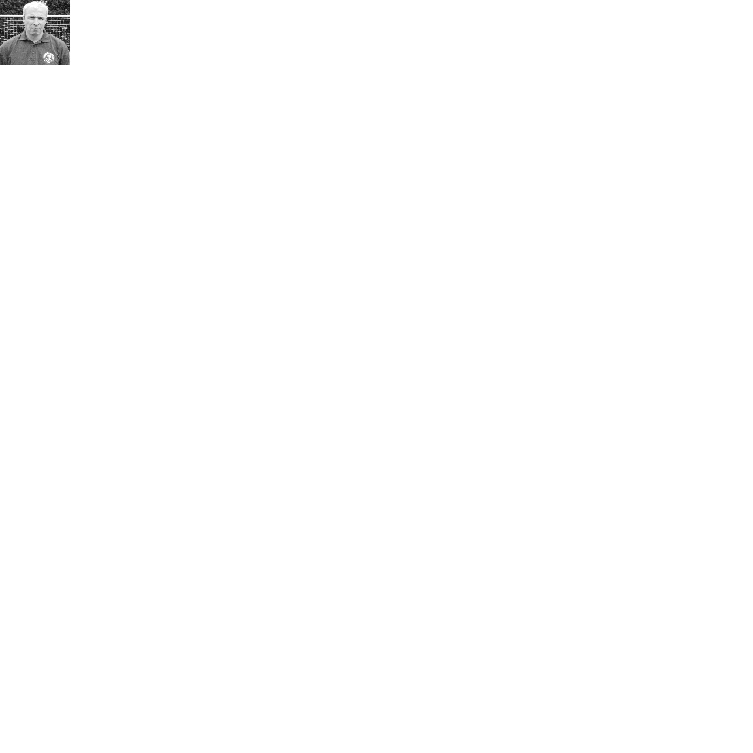
It is with deep sadness that I will be leaving Epsom & Ewell F.C after nearly eight seasons in charge. My final game will be this Saturday, against Frimley Green.

The move down to West Sussex has taken its toll on my work and family.

I leave knowing that on the pitch the club is in a better shape than when Coombsey (Tony Coombe) and I took it over, the highlight being when we won the League Cup in 2013.

I would like to take this opportunity to thank all the players, staff and officials for all their help and efforts and I wish the club all the best for the future.

Lyndon

Captain’s Corner
Our Captain, Anthony Panayi has joined our list of regular contributors, and here is his first article.

Afternoon all!

Firstly thank you all for coming to support the Salts today.

As many of you have already heard, this will be the final game for our long serving, very boring manager Lyndon Buckwell!

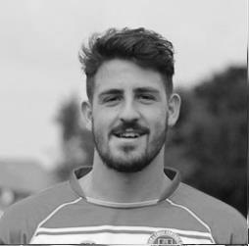
I think I speak for the whole club in applauding the great job the gaffer has done in the time he has been here. On a personal note I want to thank him for the opportunity to play for the club giving me a chance at the age of 17. I know all the former and current players will want to wish him all the best in whatever he decides to do in the future.

Moving forward, a massive congratulations to Glyn Mandeville who has been given the full time position. All the players have full respect for him and will continue to give everything for him and the club!

A much deserved win last Saturday; hoping for more of the same from today's game as we look to push up the table!

Enjoy the game and thank you for the continued support

COME ON YOU SALTS!

Ant

Club Statement
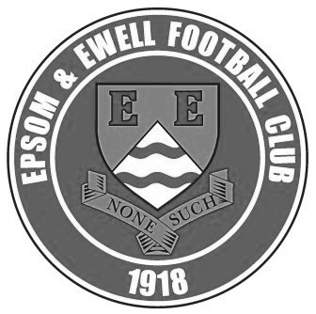
It is with regret that our long-serving Manager Lyndon Buckwell advised the club of his resignation on the afternoon of Saturday 6th September.

Epsom and Ewell F.C. would like to place on record our thanks to Lyndon for his efforts over many years at the club. He took a team that was struggling at the foot of the Combined Counties League and turned it into a perennial challenger, despite the constant uncertainty relating to the club’s battle to reclaim a home back in the Borough.

Obviously the League Cup win will be remembered as a highlight, but it should not be forgotten that we have also recorded four top five finishes in the seven full seasons he spent here. He has been the third longest serving Manager in our club’s long history and many players under his Management have made hundreds of appearances, which is a clear sign of the loyalty they had towards him.

We are pleased to announce that we have no plans to advertise the position and our current Assistant Manager Glyn Mandeville will become our next Manager. His first match in charge will be our League trip to Knaphill on the following Saturday.

We wish Lyndon all the best for the future and in conjunction with this, Saturday’s match is to be designated as a “farewell match”. It would be a fitting tribute if as many former players as possible were able to be present at Chipstead and of course we also hope that many supporters will turn out in force to wish him well.

Pete Beddoe - Chairman

All at EEFC would like to express their grateful thanks to Lyndon for all he has done on the playing field for the Club over the last eight years.

He has been a loyal servant and I still remember with affection seeing him start his career as a player down at West Street.

As a Manager he turned around a poor performing team into a most professional outfit, winning the Combined Counties League Cup in 2013 in the process.

The legacy of all your hard work is the youngest side in the Club's history which is achieving a high standard of play and improving all the time.

We all wish Lyndon a very successful future in his business and personal life and of course on the football field. Rest assured Lyndon you will always be welcome to visit us in the future, hopefully, eventually at a new home back in the Borough.

Club Statistical History - (including Hanworth Villa match on 06/09/14):
League: Played: 2,761, Won: 1,123, Drawn: 526, Lost: 1,112
For: 5,059, Against: 4,927, GD: plus 132 - Win Ratio 40.7%

CCL only: Played: 340, Won: 149, Drawn: 68, Lost: 123
For: 593, Against: 541, GD: plus 52 - Win Ratio 43.8%

Cup and Other: Played: 1,078, Won: 515, Drawn: 127, Lost: 436
For: 2,348, Against: 2,009, GD: plus 339 - Win Ratio 47.4%

Abandoned Matches: Played: 8: For: 14, Against: 16

Under Lyndon: Played 406, Won: 189, Drawn: 70, Lost: 144, Aban: 3
For: 728, Against: 647, GD: plus 81 - Win Ratio 46.6%

Total: Played 3,847, Won: 1,638, Drawn: 653, Lost: 1,548, Aban: 8
For: 7,421, Against: 6,952, GD: plus 469 - Win Ratio 42.6%

First Senior Match: 30th August 1924.
Lost 1-3 vs Dorking at our home ground at the time of Horton Hospital Grounds.

First Match Programme Issued: 15th September 1923.
Won 4-0 vs West Norwood Reserves - Friendly match at Horton Hospital Grounds.

Number of Official Home Grounds: Six.

Alexandra Recreation Ground 1918-1922,
Horton Hospital Grounds 1922-1925,
West Street 1925-1993,
Merland Rise 1993-2010,
Moatside 2010-2012,
High Road 2012- present.

Record Win: 12/10/1935. 13-1 v Reigate Priory (H) - Amateur Cup.

Record Defeat: 14/02/1948. 0-14 v Chelmsford City Reserves (A) - London League.

Longest Serving Manager: 1) Adrian Hill 853 1982-1985 & 1990-2003
2) Pat O’Connell 466 1973-1982
3) Lyndon Buckwell 406 2006-present
4) Ricky Kidd 190 1986-1990

Record Appearances: 1) Graham Morris 658 1990-2004
2) Nigel Bennett 630 1989-2005
3) Tommy Tuite 582 1973-1987
4) Ernie Watkins 419 1945-1960

Record Goal Scorers: 1) Tommy Tuite 391 1973-1987
2) Reg Marlow 254 1924-1936
3) Jimmy Jones 148 1933-1945
4) Kyle Hough 137 2007-present

Most Appearances in a season: Tony Coombe and Tommy Tuite - 59 in 1980/81.

Most goals in a season: Reg Marlow - 65 (at least) in 39 appearances in 1926/27.

Senior League Titles: 5 - 1925/26 Surrey Senior League - 1926/27 Surrey Senior League - 1927/28 London League - 1974/75 Surrey Senior League - 1977/78 Isthmian League Division Two

Results and Fixtures
F.A. Cup Extra-Preliminary Round – Saturday 30th August
Hartley Wintney | 2-1 | Frimley Green
F.A. Cup Preliminary Round – Saturday 30th August
Ashford Town (Mx) | 1-1 | Daventry Town
Cray Wanderers | 3-1 | Molesey
East Grinstead Town | 2-2 | Raynes Park Vale
Epsom & Ewell | 1-1 | Croydon
Faversham Town | 2-1 | Westfield
Hanworth Villa | 1-1 | North Greenford United
Knaphill | 2-1 | Badshot Lea
Mole Valley SCR | 1-5 | Carshalton Athletic
Windsor | 0-2 | Godalming Town
Combined Counties League – Saturday 30th August
Camberley Town | 1-2 | Cove
Colliers Wood United | 6-1 | Bedfont Sports
Farnham Town | 1-2 | Horley Town
F.A. Cup Preliminary Round – Tuesday 2nd September
Ardley United | 1-1 | Hartley Wintney
F.A. Cup Preliminary Round Replays – Tuesday 2nd September
Daventry Town | 2-1 | Ashford Town (Mx)
North Greenford United | 2-1 | Hanworth Villa
Raynes Park Vale | 2-1+ | East Grinstead Town
F.A. Cup Preliminary Round Replay – Wednesday 3rd September
Croydon | 4-1 | Epsom & Ewell
F.A. Vase First Qualifying Round – Saturday 6th September
Cove | 2-3 | Wootton Bassett Town
Hartley Wintney | 3-2 | Holyport
Holmesdale | 4-5+ | Colliers Wood United
Horley Town | 3-2 | Sevenoaks Town
Lancing | 4-1 | Mole Valley SCR
Langford | 2-2+ | Spelthorne Sports
Raynes Park Vale | 2-1 | Crowborough Athletic
Windsor | 3-0 | Shrivenham
Woodley Town | 3-0 | Badshot Lea
Combined Counties League – Saturday 6th September
Bedfont Sports | 1-2 | Camberley Town
Frimley Green | 1-3 | Ashford Town (Mx)
Guildford City | 0-2 | Chertsey Town
Hanworth Villa | 2-5 | Epsom & Ewell
Knaphill | 2-2 | Farnham Town
Molesey | 3-0 | Westfield
F.A. Cup Preliminary Round Replay – Tuesday 9th September
Hartley Wintney | 0-0+ | Ardley United
Ardley won 5-4 on penalties
F.A. Vase First Qualifying Round Replay – Tuesday 9th September
Spelthorne Sports | 4-1 | Langford
Combined Counties League – Tuesday 9th September
Badshot Lea | 0-2 | Cove
Mole Valley SCR | 4-1 | Raynes Park Vale
Combined Counties League – Wednesday 10th September
Colliers Wood United | 4-3 | Horley Town
F.A. Cup First Qualifying Round – Saturday 13th September
Knaphill | V | Fleet Town
Ramsgate | V | Raynes Park Vale
Combined Counties League – Saturday 13th September
Ashford Town (Mx) | V | Guildford City
Camberley Town | V | Colliers Wood United
Chertsey Town | V | Badshot Lea
Cove | V | Molesey
Epsom & Ewell | V | Frimley Green
Farnham Town | V | Hanworth Villa
Hartley Wintney | V | Spelthorne Sports
Horley Town | V | Bedfont Sports
Windsor | V | Mole Valley SCR
Combined Counties League Cup First Round – Tuesday 16th September
Bedfont Sports | V | Staines Lammas
Frimley Green | V | AFC Croydon Athletic
Raynes Park Vale | V | Spelthorne Sports
Sandhurst Town | V | Horley Town
Combined Counties League – Tuesday 16th September
Farnham Town | V | Mole Valley SCR
Combined Counties League – Wednesday 17th September
Chertsey Town | V | Knaphill
Guildford City | V | Badshot Lea
Combined Counties League – Saturday 20th September
Badshot Lea | V | Colliers Wood United
Cove | V | Badshot Lea
Guildford City | V | Windsor
Hanworth Villa | V | Frimley Green
Horley Town | V | Ashford Town (Mx)
Knaphill | V | Epsom & Ewell
Molesey | V | Hartley Wintney
Raynes Park Vale | V | Farnham Town
Spelthorne Sports | V | Camberley Town
Westfield | V | Chertsey Town
Combined Counties League – Tuesday 23rd September
Farnham Town | V | Cove
Frimley Green | V | Badshot Lea
Horley Town | V | Guildford City
Knaphill | V | Molesey
Mole Valley SCR | V | Hartley Wintney
Westfield | V | Epsom & Ewell
Windsor | V | Raynes Park Vale

From inside the Stand
Epsom & Ewell 1-1 Croydon – F.A. Cup Preliminary Round
Saturday 30th August 2014
Report by George Holland

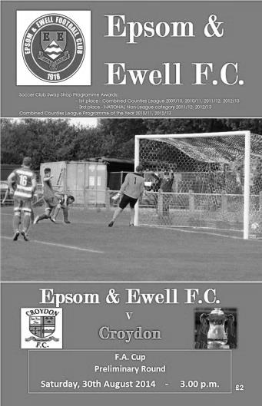
Epsom failed to derail the Trams on the long High Road to Wembley. So it's all aboard for the next stop at The Arena, Albert Road, Croydon for Wednesday night's replay at 7.45pm.

While 82 fans gathered for a local derby in this prestigious National competition, we were reminded by Richard Lambert, our Club Historian that The Salts were celebrating becoming a Senior Club 90 years ago this very day.

With Tony Ford the Combined Counties League Vice-Chairman present, the Salts also gave a debut newly signed on dual registration forms with Merstham, Goalkeeper Oshane Brown. He must be about 6 feet tall, and very imposing in goal.

The hard working Trams were first to test our Goalkeeper in the 1st minute with a deep cross for an easy catch. The Salts countered a minute later with a cross from the right which sailed just over the bar. Dewar tested their keeper Ameyaw on 12 minutes following a good passing move in midfield. Ameyaw made an easy low save.

Brown saw a Trams header drift wide on 13 minutes, before both sides created and wasted some promising moves. The Trams goal survived a scare on the half hour when a looping ball went goalwards, the ball was cleared off the line and away.

More chances were spurned before the Salts took the lead on 39 minutes spectacularly. Dewar played the ball in from the right wing into a crowded area, and Taylor Smith's acrobatic scissor kick flew past their keeper into

the net for a 1-0 lead. Smith's shot on 45 minutes was deflected for a corner which was cleared. And so the Salts reached the interval on the front foot.

The second half saw Croydon dominate the best chances and the Salts go back into their shell and waste attacks with some wayward passes and free kicks. The Trams were first to test Brown on 48 minutes with an unnecessary corner which was dealt with. Farrell drew a low save from Ameyaw a minute later. Hoadley and Dewar combined on the hour for Hough to shoot. The resulting corner saw Panayi head wide.

Smith's run and shot on 61 minutes drew another low save, before the Trams had a free kick on the left a minute later. This produced a shot that went well over. However, they were now pushing the Salts back. And on 73 minutes a free kick, centrally, from 30 yards out, cannoned off Brown's crossbar before he punched it clear.

More chances came and went until Dewar headed straight at Ameyaw on 81 minutes. Then a minute lateral Trams corner produced a header that was cleared off the line.

With five minutes left, Douglin countered down the right, cut in, and unleashed a fizzing left footer just over the bar. However, the Trams hard work bore fruit on 87 minutes with the equaliser. Their free kick was sent out wide, the ball was crossed back in and their Captain, Waters, rose highest and unmarked to send a bullet header home for 1-1.

Going into five minutes of injury time, the Salts were defending deeply, before the referee blew for time. And so the teams do it all again on Wednesday. It's The Cup that keeps on giving.

Line Up: Brown, Taylor, Tanton, Panayi (c), Dean, Hayward, Dewar, Hoadley, T.Smith, Hough, Farrell, 12 Gaffney, 14 Downs, 15 Murphy, 16 White, 17 Marvell, 18 Van Gelder.

Subs: Marvell for Smith (70), Downs for Hoadley (80), White for Dewar (90)

Booked: Taylor and Tanton.

From behind the goal
Croydon 4-1 Epsom & Ewell – F.A. Cup Preliminary Round Replay
Saturday 30th August 2014

Cup dreams destroyed by Croydon's rapid response

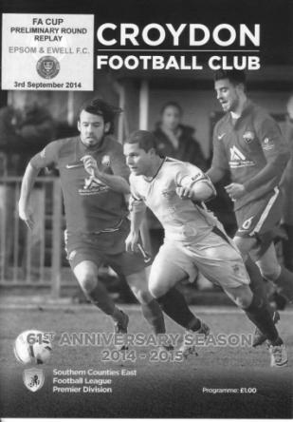
It is always disappointing to go out of the F.A. Cup, even more so when you have to visit one of the least inspiring venues in the country to do it. However, the saddest part about yesterday's defeat was that we competed with Croydon for quite a while, and as with the first game, held the lead, but were let down by errors in concentration and maybe just a bit of belief.

For make no mistake here, this game was very close for fifty five minutes and absolutely there for the taking, along with the prize money and home tie with Burgess Hill Town in the next round that it would have earned.

Both teams were missing one regular first teamer as Dale Marvell was absent for us and Dan Jupe was injured for the hosts. Sam Robinson and Michael Eacott returned from holiday but found themselves on the bench, while Oshane Brown, recently joined from Merstham retained his spot between the posts. For the opposition we had two former Salts as both Karl Douglin and Zach Powell faced us for the second time in a week.

The first half was a bitty affair. Both teams looked good in patches and had chances in amongst large periods of the game where they cancelled each other out. Our best chances fell to Ben Hayward, the first of which from an Ali Dewar cross found him in space on the edge of the box after just 9 minutes, but he was unable to get any power on the shot. Both teams appeared to want to play on the counter attack and there was a lot of pace on display, most notably from Lauris Chin for Croydon and Taylor Smith for us. An Epsom corner was met by a header from Dan Dean but he couldn't keep the ball down after 18 minutes before a long throw from Matt Tanton was flicked on by Smith and required a rapid clearance before we could cause any further danger.

The hosts also caused concerns for our boys with Brown able to gather a low shot at the second attempt, and just before half time a low free kick was well blocked by our keeper. As the half ended, Ben Mankelow for Croydon got through on the right but Brown saved well once again. Ironically, Mankelow

only had the opportunity due to three minutes injury time as a result of a solid challenge that left him requiring treatment.

As the half concluded the hosts were just beginning to get on top, but it was a tight game and with defences performing admirably, I felt that the first goal, if indeed one was coming at all, would be really important in deciding this tie. How wrong I would be!

With Smith and Dewar swapping wings at the start of the second half we got back on top in the second half and a Smith cross found Kyle Hough, playing in a more advanced role but he didn't connect as well as he would have liked and although Francis Ameyaw made the save, pushing the ball out for a corner, you wondered whether a sweeter strike would have had to much for him. Would we regret our missed opportunity? It appeared not as after 53 minutes a James Taylor right wing cross found Dewar right on the edge of the box and his shot flew into the top corner to give us the lead. In a tight match with few real chances, this was just the break we needed, but would we be able to last the remaining 37 minutes?

As it turned out we were unable to survive for 37 seconds as a hopeful ball into the box fell between keeper and defender and as neither claimed it, Chin nipped in, poking the ball into the net. Under normal circumstances this shouldn't have been a problem as we had been on top and we should have just continued where we left off but they scored again after 55 minutes following a great run from their centre half. Smith tracked back with him, and held him up so that he released the ball to a team mate. However, he then continued his run, leaving our man behind and when he got it back he squared the ball for the incoming Tristan Toney to side foot the ball past Brown.

After 61 minutes we conceded again, this time disappointingly to an unmarked header by Steve Cox from a corner and as we pushed forward to try and get anything from the game we conceded a fourth after 76 minutes when Mankelow got free on the left and cutting in, curled the ball over the exposed Brown.

I believe that if we had gone into the game with a little more confidence that we would have seen off Croydon, probably without the need for a replay, but with a young side confidence is key and recent League results didn't help that. Croydon had also suffered recent League defeats but maybe had a bit more experience and their rapid equaliser proved pivotal in the whole proceedings. We do have a decent team this season, but right now it looks as though we are not reaching our potential and that needs to change soon with a tough League trip to Hanworth Villa up next.

Lyndon Buckwell – 407 today!
Here is a review of Lyndon’s time with us.

Some of this article has recently been used in a similar item to mark Lyndon’s 400th game in charge, so apologies in advance for any duplication.

Lyndon Roy Buckwell was born on 9th January 1969 and first played for Epsom & Ewell on Tuesday 4th October 1988 at West Street in a 3-0 home win over Horsham. Lyndon was mostly a full back in his time with us and our Manager at the time was Ricky Kidd.

Ricky was quite keen on putting some of our better players on contract, and on 7th February 1989 Lyndon signed one with the club, paying the princely sum of £8 per week with a financial bonus of £3 for every appearance for the First Eleven!

We played in the Isthmian League Second Division South at the time and Lyndon made twenty appearances that term. He was more involved the following term when he made forty appearances which, along with Neil Robson, was the most by any player that season. Kidd departed in March 1990 and while many players left at that time, Lyndon remained under the returning Manager Adrian Hill, playing the final nine games of the season.

In 1990/91, he was joined at the club by his younger brother Scott and on 29th September 1990 at Eastbourne, both brothers took the field for the First Eleven at the same time, a feat that doesn’t happen very often. Incredibly, on 20th October 1990, we then had two pairs of brothers on the field, as the Buckwells were joined by the Boxall brothers Andy and Jeremy and all four played in the next six matches as well!

Unfortunately on 13th April 1991, Lyndon tore ligaments in the first half of the match against Leatherhead and we just missed out on a top half finish, which due to League reorganisation meant an effective relegation to the Isthmian League Division Three.

However, Lyndon was destined to play at a higher level than that and left the club for Kingstonian the following season with his tally of appearances at 98. He also went on to play for Molesey and Corinthian Casuals with much success

before stepping into Management at Casuals with the Reserve Team alongside another former player and Legend Tony Coombe who has remained by his side ever since.

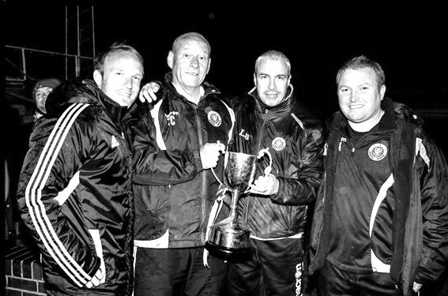
Upon the dismissal of Paul Pritchard in the early part of 2006/07 Lyndon became just our eighth different Manager in forty years. Under his tenure, things have improved greatly with four top five finishes in the League and of course, a League Cup win in May 2013; our first trophy since 1981.

Despite advancing years in playing terms, Lyndon also found himself called into action on two occasions as a player, enabling him to reach the 100 appearance mark. Unfortunately his final outing at Farnborough’s Cherrywood Road against Badshot Lea resulted in a harsh sending off by an inexperienced referee, giving him the unfortunate record of being the oldest player ever sent off for us at the age of 41 years and 112 days.

And now as of today, it’s all over. They say nothing lasts forever and only memories remain but there are many. Personally, I will always remember the subsequent visit Lyndon made to Farnborough’s ground for a certain League Cup Final in 2013 against South Park, when we defeated them 3-0 to lift our first silverware since 1981, a span of 1,651 games!

Thanks Lyndon and good luck!

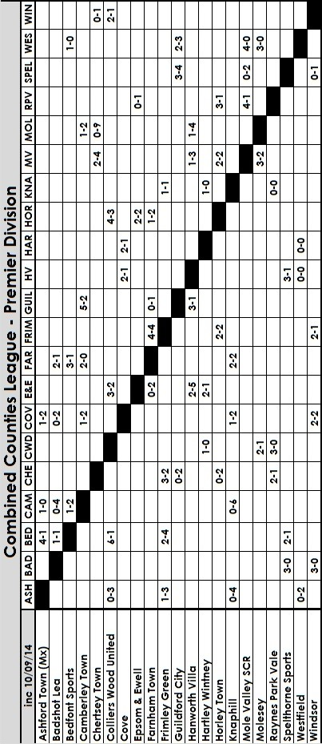

First Eleven Appearances - (max 9 inc Hanworth Villa)
Name | Debut | 2014/15 |  |  |  | Career Totals
Name | Debut | App | Sub | Total | Goals | App | Sub | Total | Goals
BROWN Oshane* | 30/08/2014 | 2 | 0 | 2 | 0 | 2 | 0 | 2 | 0
CURRIE Sam | 04/08/2012 | 2 | 0 | 2 | 0 | 96 | 5 | 101 | 2
DEAN Dan | 02/08/2014 | 7 | 0 | 7 | 0 | 7 | 0 | 7 | 0
DEWAR Ali | 29/10/2011 | 4 | 1 | 5 | 3 | 54 | 30 | 84 | 10
DOUGLIN Karl* | 03/08/2034 | 1 | 0 | 1 | 1 | 41 | 3 | 44 | 14
DOWNS Carl* | 17/09/2011 | 4 | 1 | 5 | 0 | 94 | 13 | 107 | 2
EACOTT Michael | 02/08/2014 | 7 | 0 | 7 | 0 | 7 | 0 | 7 | 0
FARRELL Matt | 02/08/2014 | 8 | 0 | 9 | 1 | 8 | 0 | 9 | 1
GAFFNEY Luke | 16/08/2014 | 1 | 1 | 2 | 0 | 1 | 1 | 2 | 0
HARPER Tommy | 15/04/2014 | 1 | 0 | 1 | 0 | 2 | 1 | 3 | 0
HAYWARD Ben | 07/03/2007 | 5 | 0 | 5 | 0 | 241 | 28 | 269 | 18
HOADLEY Harry | 15/04/2014 | 6 | 1 | 7 | 0 | 7 | 1 | 8 | 0
HOUGH Kyle | 14/08/2007 | 8 | 0 | 8 | 0 | 262 | 12 | 274 | 137
JARMAN Mark | 08/08/2009 | 0 | 3 | 3 | 0 | 131 | 49 | 180 | 76
MARVELL Dale | 15/01/2000 | 4 | 2 | 6 | 3 | 254 | 42 | 296 | 83
MURPHY George | 28/03/2013 | 4 | 1 | 5 | 0 | 45 | 5 | 50 | 2
MUTIMA Lionel | 05/08/2014 | 1 | 2 | 3 | 0 | 1 | 2 | 3 | 0
NELMES Elliott* | 05/08/2014 | 2 | 0 | 2 | 0 | 2 | 0 | 2 | 0
PANAYI Anthony | 14/11/2010 | 7 | 0 | 7 | 0 | 134 | 14 | 148 | 4
ROBINSON Sam | 22/10/11 | 4 | 1 | 5 | 3 | 28 | 4 | 32 | 8
SMITH Taylor | 02/08/2014 | 8 | 0 | 8 | 4 | 8 | 0 | 8 | 4
TANTON Matt | 02/08/2014 | 6 | 0 | 6 | 0 | 6 | 0 | 6 | 0
TAYLOR James | 26/08/2013 | 6 | 0 | 6 | 1 | 23 | 6 | 29 | 2
VAN GELDER Julian | 12/09/2006 | 0 | 1 | 1 | 0 | 0 | 2 | 2 | 0
WHITE Sean | 02/08/2014 | 1 | 5 | 6 | 0 | 1 | 5 | 6 | 0
* Player has left the club

Club Records - 13th September
Date | Day | Competition |  | Opponents |  | Scorers
13/09/24 | Sat | Surrey Senior League | A | Farnham United Breweries | 4-0 | J.Parr, R.Marlow (2), F.Watts
13/09/30 | Sat | London League | A | Erith & Belvedere | 4-1 | T.Jones, W.Challis, E.Matkin, F.Behn
13/09/47 | Sat | London League | H | Edmonton Borough | 2-2 | W.Webber (2)
13/09/52 | Sat | FA Cup Prelim | H | Dulwich Hamlet | 2-2 | J.Hoy (pen), B.Goddard
13/09/58 | Sat | Corinthian League | H | Slough Town | 1-2 | T.Higgins
13/09/69 | Sat | Amateur Cup Prelim | A | Lion Sports | 0-0
13/09/72 | Wed | Southern Combination Cup 1 | H | Wandsworth | 0-0
13/09/75 | Sat | FA Cup 1q | A | Southall & Ealing Borough | 1-1 | T.Lee
13/09/80 | Sat | FA Cup 1q | H | Eastbourne Town | 1-0 | T.Coombe
13/09/83 | Tue | Isthmian League 1 | H | Lewes | 1-1 | S.Hill
13/09/86 | Sat | Isthmian League 1 | H | Leatherhead | 0-1
13/09/88 | Tue | Isthmian League Cup 1 | A | St Albans City | 0-5
13/09/89 | Wed | Isthmian League Cup  Prelim Round replay | A | Collier Row | 3-4 | S.Alldridge, C.Holding (2)
13/09/94 | Tue | Southern Combination Cup Prelim Round | A | Walton & Hersham | 1-1 | G.Morris (pen)
13/09/97 | Sat | Isthmian League 3 | H | Tring Town | 1-2 | A.Boxall
13/09/08 | Sat | FA Cup 1q | A | Burgess Hill Town | 2-5 | R.Burns, A.Rodrigues
Historical Decades
90 years ago – Epsom Town
13/09/24 | Sat | Surrey Senior League | A | Farnham United Breweries | 4-0 | J.Parr, R.Marlow (2), F.Watts
80 years ago – Epsom F.C.
15/09/34 | Sat | FA Cup Prelim | A | Redhill | 6-3 | T.Dunne (2), M.Wiggins (2), E.Hannam, R.Marlow
60 years ago – Epsom F.C.
11/09/54 | Sat | FA Cup Prelim | A | Dorking | 3-1 | B.Avis, M.Simmonds, B.Canham
50 years ago – Epsom & Ewell F.C.
12/09/64 | Sat | Athenian League 1 | A | Harlow Town | 3-7 | N.Dearlove (2), T.Higgins
40 years ago – Epsom & Ewell F.C.
14/09/74 | Sat | FA Cup 1q | A | Redhill | 0-3
30 years ago – Epsom & Ewell F.C.
11/09/84 | Tue | Isthmian League Prem | A | Sutton United | 4-5 | J.Raffington, S.Milton, C.Miles (pen), S.Hill
20 years ago – Epsom & Ewell F.C.
13/09/94 | Tue | Southern Combination Cup Prelim Round | A | Walton & Hersham | 1-1 | G.Morris (pen)

History Corner – 13th September
90 years ago today we announced ourselves on the stage, in football terms when we travelled to Farnham United Breweries, the defending League and Cup holders and battered them 4-0 on their own patch. Reg Marlow, scored twice on his debut and we handed them a bit of a lesson, although they would return the favour with a 2-0 win at Horton, going on to repeat their double from the previous season. Our time was coming soon though.

80 years ago this week we were keen to repeat our F.A. Cup heroics of the previous season and having defeated Carshalton Athletic 3-0 on their own patch, we registered another three goal win in emphatic style, defeating Redhill 6-3 at West Street. Tommy Dunne and Michael Wiggins got two goals each as we led 3-0 at the half. However, whilst we would also get past Streatham Town, Guildford City knocked us out and went on to reach the First Round themselves.

62 years ago today over 3,000 were at West Street to watch the new look Epsom, under the guidance of Player / Coach Pat Lynch the former English Amateur International as we took on the mighty Dulwich Hamlet in the F.A. Cup. The papers reported that Epsom were superior for Dulwich but had to settle for a draw and we lost the replay 2-4 at Champion Hill.

60 years ago this week we broke the ground record at Dorking’s Meadowbank ground for an F.A. Cup tie that was won 3-1 with goals from Mick Simmonds, Bobby Avis and Bernard Canham. The ground was just over a year old but it was our second win, having already won there in a Cup replay the previous season. An attendance of 2,400 is hard to imagine there but that’s what it was! (see programme right)

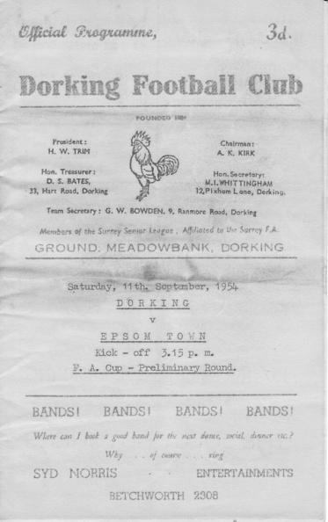
40 years ago this week our super team actually lost a match! After opening up the season with seven League wins and a goal difference of F26 A1 we found Athenian League Redhill a much tougher prospect and they beat us 3-0 in this F.A. Cup tie. Involved with Redhill this day as Manager was former player Don Hollands while future players Dick Vincent, Alex Reid and Barry Denman all played against us.

34 years ago today we opened up our F.A. Cup campaign with a 1-0 home win over Eastbourne United. Not particularly notable, although subsequent wins over Margate (with a young David Elleray as referee!) and Ashford Town enabled us to make only our second ever appearance in the Fourth and final qualifying round, where we drew the short straw in Enfield, who beat us 5-0 on their way to a Fourth round replay with Barnsley at White Hart Lane. We would have been at home to Wembley in the First round and then at home to Hereford United!

6 years ago today we travelled to Burgess Hill Town for an F.A. Cup tie and with key players missing we were in real trouble at 3-0 down. However, a great finish from Robbie Burns and a thumping header from Alex Rodrigues of all people got us back in the game but as we pushed for a replay we were caught by two late goals. Of course, had we beaten Croydon we would have been facing the Hillians again today!

CCL Premier Division Club Directory
ASHFORD TOWN (Mx) Telephone: 01784-245908 - Ground: The Robert Parker Stadium, Short Lane, Stanwell. TW19 7BH - Colours: Tangerine & White Stripes/Black/Tangerine

BADSHOT LEA Telephone: 01252-320385 - Ground: Ash United FC, Shawfield Stadium, Youngs Drive, Shawfields Road, Ash, Hampshire. GU12 6RE - Colours: Claret/White/Claret

BEDFONT SPORTS Telephone: 0208-831-9067 - Ground: Bedfont Sports Club, Hatton Road, Bedfont, Middx TW14 8JA - Colours: Red & Black Hoops/Black/Red & Black Hoops

CAMBERLEY TOWN Telephone: 01276-65392 - Ground: Krooner Park, Wilton Road, Camberley, Surrey. GU15 2QW - Colours: Red & White Stripes/Blue/Red

CHERTSEY TOWN Telephone: 01932-561774 - Ground: Alwyns Lane, Chertsey, Surrey. KT16 9DW - Colours: Royal Blue & White Stripes/Royal Blue/Royal Blue

COLLIERS WOOD UNITED Telephone: 0208-942 8062 - Ground: Wibbandune Sports Ground, Lincoln Green, Opposite 199-213, Robin Hood Way, Wimbledon. SW20 0AA - Colours: Blue & Black Stripes/Black/Black

COVE Telephone: 01252-543615 - Ground: Oak Farm Fields, 7 Squirrel Lane, Cove, Farnborough, Hampshire. GU14 8PB - Colours: Yellow/Black/Yellow

EPSOM & EWELL Telephone: 01737-553250 - Ground: Chipstead FC, High Road, Chipstead, Surrey. CR5 3SF - Colours: Royal Blue & White Hoops/Royal Blue/Royal Blue & White Hoops

FARNHAM TOWN Telephone: 01252-715305 Ground: Memorial Ground, Babbs Mead, West Street, Farnham, Surrey. GU9 7DY Colours: - Claret & Sky Blue /White/ Claret & Sky Blue

FRIMLEY GREEN Telephone: 01252-835089 - Ground: Frimley Green Recreation Ground, Frimley Green Road, Frimley Green, Camberley, Surrey. GU16 6JY - Colours: Blue & White/Blue/Blue

GUILDFORD CITY Telephone: 01483-443322 - Ground: The Spectrum, Parkway, Guildford, Surrey. GU1 1UP - Colours: Red & White Stripes/Black/Black

HANWORTH VILLA Telephone: 0208-831-9391 - Ground: Rectory Meadows, Park Road, off Hounslow Road, Hanworth, Middlesex. TW13 6PN - Colours: Red & White Stripes/Black/Black

HARTLEY WINTNEY Telephone: 01252-843586 - Ground: Memorial Playing Fields, Green Lane, Hartley Wintney, Hants RG27 8DL - Colours: Orange & Black/ Orange /Orange

HORLEY TOWN Telephone: 01293-822000 - Ground: The New Defence, Anderson Way, Court Lodge Road, Horley, Surrey. RH6 8SP - Colours: Claret & Sky Blue/Claret/Claret

KNAPHILL Telephone: 01483-475150 - Ground: Brookwood Country Park, Redding Way, Lower Guildford Road, Knaphill, Surrey. GU21 2AY - Colours: Red/Black/Red

MOLE VALLEY SCR Telephone: 01932-866386 - Ground: Cobham FC, Leg O’Mutton Field, Anvil Lane, Downside Bridge Road, Cobham, Surrey KT11 1AA - Colours: Yellow/Black/Black

MOLESEY Telephone: 0208-979-4283 - Ground: 412 Walton Road, West Molesey, Surrey KT8 2JG - Colours: White/Black/Black

RAYNES PARK VALE Telephone: 020-8540-8843 - Ground: Prince Georges Playing Field, Grand Drive, Raynes Park, London. SW20 9NB - Colours: Blue/Blue/Red

SPELTHORNE SPORTS Telephone: 01932-961055 - Ground: Spelthorne Sports Club, 296 Staines Road, Ashford Common, Ashford, Middx. TW15 1RY - Colours: Light & Dark Blue/Dark Blue/Light Blue

WESTFIELD Telephone: 01483-771106 - Ground: Woking Park, Kingfield Road, Woking, Surrey. GU22 9BA - Colours: Yellow/Black/Black

WINDSOR Telephone: 01753-860656 - Ground: Stag Meadow, St Leonards Road, Windsor, Berks SL4 3DR - Colours: Red/Red/Red

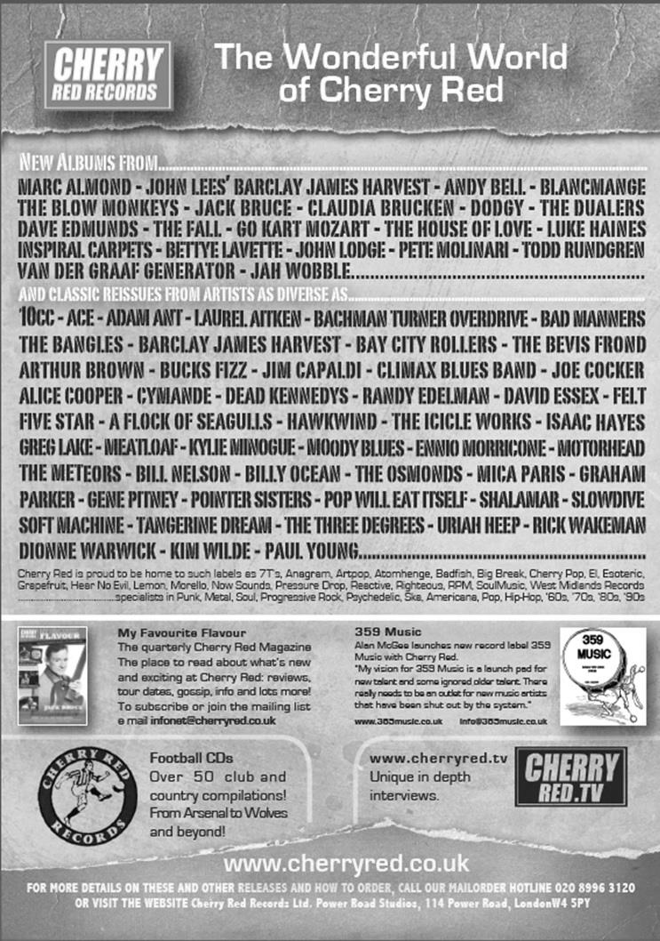

Centre page for results

Centre page for results

Frimley Green – History
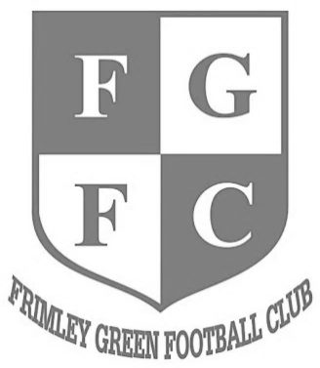
The club was founded in 1919 and currently play at Frimley Green Recreation Ground.

The present clubhouse was erected in 1972 when ‘The Green’ played in the London Spartan League and used a pitch on the lower part of the park with the changing rooms where the car park now is. A few years later a new pitch was laid adjacent to the clubhouse and changing rooms were added.

The Reserve Team joined the Combined Counties League in 1979 and at the start of the 1981/82 season the First Team switched across and Floodlights were installed for the first time. The Club competed in the League for a period of 15 years, during which time they won the Dan Air Elite Cup and the Reserves won the Division One Challenge Cup.

Due to the financial situation in 1994 the club voluntarily dropped down into junior football. They were Runners-up in the Surrey Intermediate League (Western) in their first season but were denied promotion into the Surrey Premier League. The next four seasons saw a period of rebuilding and repaying debts and the club were finally accepted into the Surrey Premier League in 1999, after finishing Runners-up and winning the League Cup. Off the field new Floodlights were installed and a Boardroom created within the Clubhouse.

A three year spell followed, in the renamed Surrey Senior League, which saw the club finish fourth, sixth and Runners –up and attain promotion back into the Combined Counties League where they have played since. Season 2004-05 was the most successful to date, in the Combined Counties League, with the club finishing in 15th Place and amassing 58 points.

Season 2005-06 was very disappointing on the playing front but we managed to avoid finishing in a relegation position, however, despite substantial ground improvements we were demoted on ‘ground grading’, to make way for 7 clubs from the old Ryman Division two (including Epsom & Ewell – sorry about that!).

In the next four seasons in Division One we had mixed fortunes, finishing 6th at the end of season 2007/08 but in season 2008/09 finishing 3rd from bottom, although we had our most successful season ever in the FA Vase, reaching the third round and won an F.A. Cup match for the first time.

In season 2009/10 we managed to finish high enough up the table to retain our F.A. Cup place but 2010/11 was a poor season. 2011/12 saw the appointment of Paul Miles and Ian Maynard mid-season and they built a team to challenge for promotion in 2012/13.

We did better than expected and won the title and 3 F.A. Vase games along the way, beating two level 5 opponents. Last season both Paul & Ian left us and Derren Martin took charge and we finished in a creditable mid table position, a good outcome for our first season back.

Match and Ball Sponsorships – 2014/15
Opponent | Date | Match Sponsor | Ball Sponsor
Raynes Park Vale | 05/08/14 | Club President - Stella Lamont
Horley Town | 25/08/14 | Epsom & Ewell F.C. Management Committee
Croydon (FAC) | 30/08/14 | Media Officer - Richard Lambert
Frimley Green | 13/09/14 | Dave Gaffney and friends
Guildford City | 30/09/14
Mole Valley SCR | 07/10/14 | Provisional date
Bedfont Sports | 11/10/14 | Epsom & Ewell F.C. Colts
Knaphill (LC) | 14/10/14
Ashford Town (Mx) | 18/10/14
Chertsey Town | 28/10/14
F.A. Vase - 1st Round | 01/11/14 | If drawn at home
Spelthorne Sports | 11/11/14
Molesey | 22/11/14 | Provisional and dependent on Vase progress
Camberley Town (SSC) | 02/12/14 | Provisional date
Hanworth Villa | 06/12/14
Windsor | 03/01/15
Farnham Town | 17/01/15
Westfield | 31/01/15
Camberley Town | 07/02/15
Hartley Wintney | 21/02/15
Cove | 07/03/15
Badshot Lea | 21/03/15
Colliers Wood United | 04/04/15
Knaphill | 18/04/15
For League Matches:

Match sponsorship - £40.00 Match ball sponsorship - £25.00.
Combined Offer of Match and Match Ball sponsorship for £55.00.

For Cup Matches:

Match sponsorship - £50.00 Match ball sponsorship - £30.00.
Combined Offer of Match and Match Ball sponsorship for £65.00.
----------------------------------------------------------------------------------------------------------------
Sponsorship includes

Admission, programmes, advertising (if required) and hospitality.

If you are interested, just speak to a Committee Member, you know where we are!
Alternatively, drop an email to richard.c.lambert@virgin.net

From behind the goal
Hanworth Villa 2-5 Epsom & Ewell – Combined Counties League Premier Division
Saturday 30th August 2014

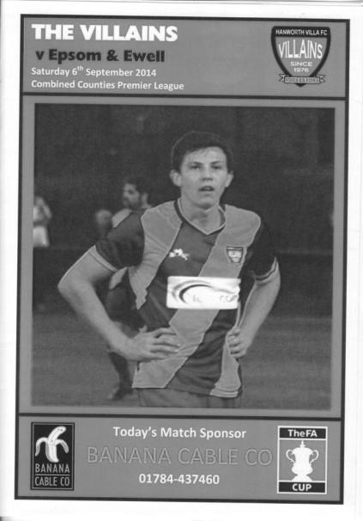
The Ranch remains a happy hunting ground as the Salts score five

Bouncebackability! It is a term that we haven't heard so much recently but it is the perfect word to describe the turnaround in three days from our F.A. Cup exit at Croydon.

Despite the disappointment of the previous result and the unavailability of a number of first teamers for various reasons, Lyndon's change of formation in moving Kyle Hough up alongside Taylor Smith was an attacking tactic that clearly worked at Rectory Meadows, better known as the Ranch. It also provided opportunities for Sam Robinson to get forward and he took full advantage with three great goals himself.

The change worked almost immediately. With fractionally over two minutes completed in the game Taylor Smith sent in a deep cross field ball and Robinson got onto the end of it to head it past the home keeper. Their defender Baines was close to getting his head to it himself but was able to claim the Villa equaliser just over a minute later when he was on the end of a clever pass and he clipped the ball over Michael Eacott with the composure of a regular striker.

Having conceded so soon and with memories of the same thing happening at Croydon, our boys could have struggled at this point but we got back on top quickly and from a break on the left, a low cross found Harry Hoadley in a lot of space on the edge of the area. Although he didn't make the best contact with the ball, it found Smith in space and he drilled the ball low past Dane Buss for our second goal in just the eighth minute.

We continued to put pressure on the home side and from a break by Smith on the left he fed Tanton who beat two men with one move before crossing to Hoadley but the keeper just got a hand to it before it reached him for what

would almost certainly have been a goal. Hough went down in the area shortly afterwards following more good work from Hoadley and Tanton but the referee was well placed to decide that there was no foul.

Robinson was all over the park today and from his back flick Smith had a goal bound shot blocked at the last moment before Tanton, playing much further forward than previously, got a low shot in that the keeper gathered low to his left. After 42 minutes Hoadley was put through by a clever Hough pass but his shot was tipped around the post by Buss. However, it was of little use as the corner came in and Tanton met it with a stunning volley from about eight yards, and whilst a bit of marking would have made it more difficult, it was still a superb strike, the first of many we would see today.

Ali Dewar lashed a shot at goal just nine seconds into the second half as we announced our intent to keep attacking but we had an escape after 54 minutes when George Murphy, making his 50th appearance, appeared to bring down a home striker inside the area, and although the official decision was a free kick just outside the box, from the angle I had, we dodged a bullet there.

Five minutes later Robinson started and finished the move that would make the score 4-1. He jumped highest for a high ball that had been skied by a defender and his header went on to Hough who ran down the left and crossed the ball in. The ball was just behind the incoming Matt Farrell but we had others behind him, one of whom was Robinson and he hit the ball with the outside of his foot straight into the top corner from just inside the box.

Bearing in mind that our two previous visits here had seen us concede twice right near the end, it was nice to see us with a three goal lead this time, and Robinson completed his hat trick to make it 5-1 after 81 minutes with another great low shot from the edge of the area after the ball had been laid back to him; the shot flying in off the near post giving the keeper no chance.

There was still time for the obligatory late Hanworth Villa goal as Osuhor also struck a beauty into the top corner of Eacott's goal in the 92nd minute and incredibly they had another good chance as their striker broke through on goal but shot wide. Either way, there was no way back for them this time and a 5-2 score line was totally justified as Epsom's young guns showed there is real potential in this group.

Line Up: Michael Eacott, James Taylor, Matt Tanton, Anthony Panayi ©, George Murphy, Harry Hoadley, Ali Dewar, Sam Robinson, Taylor Smith, Kyle Hough, Matt Farrell

Subs: Sean White for Hoadley (57), Lionel Mutima for Dewar (81), Luke Gaffney for Tanton (86)

Booked: Farrell

Above and Below
Ryman League Division One South Table
inc Saturday 6th September | P | W | D | L | F | A | Pts | GD
Burgess Hill Town | 8 | 5 | 3 | 0 | 19 | 9 | 18 | +10
Corinthian-Casuals | 8 | 5 | 1 | 2 | 17 | 11 | 16 | +6
Faversham Town | 7 | 5 | 0 | 2 | 17 | 9 | 15 | +8
Chipstead | 6 | 5 | 0 | 1 | 13 | 6 | 15 | +7
Whyteleafe | 7 | 4 | 2 | 1 | 10 | 5 | 14 | +5
Sittingbourne | 8 | 4 | 2 | 2 | 12 | 8 | 14 | +4
Whitstable Town | 7 | 3 | 4 | 0 | 14 | 10 | 13 | +4
Folkestone Invicta | 7 | 3 | 3 | 1 | 11 | 9 | 12 | +2
Herne Bay | 8 | 3 | 2 | 3 | 10 | 12 | 11 | -2
Merstham | 8 | 2 | 4 | 2 | 16 | 12 | 10 | +4
Tooting & Mitcham Utd | 7 | 3 | 1 | 3 | 12 | 8 | 10 | +4
Guernsey | 8 | 3 | 1 | 4 | 17 | 18 | 10 | -1
South Park | 8 | 3 | 1 | 4 | 12 | 16 | 10 | -4
Ramsgate | 7 | 3 | 0 | 4 | 8 | 10 | 9 | -2
Carshalton Athletic | 8 | 2 | 3 | 3 | 5 | 7 | 9 | -2
Hastings United | 8 | 2 | 3 | 3 | 9 | 12 | 9 | -3
Three Bridges | 7 | 2 | 3 | 2 | 8 | 16 | 9 | -8
Worthing | 6 | 2 | 2 | 2 | 7 | 8 | 8 | -1
Hythe Town | 7 | 2 | 1 | 4 | 9 | 9 | 7 | 0
East Grinstead Town | 7 | 2 | 1 | 4 | 10 | 13 | 7 | -3
Walton & Hersham | 8 | 2 | 1 | 5 | 9 | 17 | 7 | -8
Redhill | 7 | 1 | 2 | 4 | 14 | 16 | 5 | -2
Horsham | 7 | 1 | 2 | 4 | 7 | 11 | 5 | -4
Walton Casuals | 7 | 0 | 0 | 7 | 6 | 20 | 0 | -14
The first thing to note is that we could have been home to divisional leaders Burgess Hill Town today in an F.A. Cup tie and it will certainly be interesting to see how Croydon get on today.

The next thing I thought was “what are Corinthian Casuals doing up there?” As a perennial bottom-six club, in the last week they have defeated Guernsey and Redhill, so this indicates that there has been quite a turnaround at King George’s field. Also, Chipstead have started well.

Guernsey are only midway up the table although last season’s runners up, Folkestone Invicta are nicely placed at this stage. Less impressive so far have been Carshalton Athletic, and when you bear in mind that the other clubs relegated from the Isthmian League Premier Division went into the North Division (Thamesmead Town & Cray Wanderers), this either shows how competitive this division is, or how far the Robins have slipped recently, as I had them as clear favourites to bounce straight back, whatever their off field troubles may have been.

Of the three promoted clubs, Whyteleafe appear to be very competitive at this level, while South Park are settling in and should also survive comfortably. East Grinstead Town are more precariously placed, and having only moved up as runners-up due to East Preston failing the grade in the Sussex League, this may prove to be a step too far for the Wasps.

That said, Walton Casuals are setting the bench mark so far with seven straight defeats and if they keep this form up they will be certainties to join us down here next season!

Above and Below
Combined Counties League Division One Table
inc Saturday 6th September | P | W | D | L | F | A | Pts | GD
Worcester Park | 5 | 4 | 1 | 0 | 13 | 5 | 13 | +8
Farleigh Rovers | 6 | 4 | 1 | 1 | 14 | 7 | 13 | +7
Banstead Athletic | 5 | 3 | 1 | 1 | 7 | 5 | 10 | +2
AFC Croydon Athletic | 5 | 3 | 0 | 2 | 14 | 9 | 9 | +5
Bedfont & Feltham | 3 | 3 | 0 | 0 | 4 | 1 | 9 | +3
Ash United | 4 | 1 | 3 | 0 | 6 | 5 | 6 | +1
Cobham | 6 | 2 | 0 | 4 | 10 | 10 | 6 | 0
Dorking | 5 | 2 | 0 | 3 | 10 | 11 | 6 | -1
Eversley & California | 5 | 2 | 0 | 3 | 9 | 12 | 6 | -3
Sandhurst Town | 6 | 2 | 0 | 4 | 9 | 18 | 6 | -9
Alton Town | 4 | 1 | 2 | 1 | 9 | 9 | 5 | 0
CB Hounslow United | 5 | 1 | 2 | 2 | 4 | 6 | 5 | -2
Sheerwater | 6 | 1 | 2 | 3 | 7 | 10 | 5 | -3
Epsom Athletic | 5 | 1 | 2 | 2 | 12 | 16 | 5 | -4
Chessington & Hook United | 3 | 1 | 0 | 2 | 7 | 7 | 3 | 0
Staines Lammas | 3 | 0 | 0 | 3 | 3 | 7 | 0 | -4
This division is even more difficult to call than the one above us!

When I was asked to name my three teams for promotion at the start of the season, I would have said that Ash and Alton would bounce back with AFC Croydon Athletic being close, especially as they return to their old ground shortly. This was predicted before Eversley & California were dropped back into the equation, but none of those teams currently occupy a place at this, admittedly early stage.

So all credit to the top three so far, none of whom I thought would be in the top half. That said, Worcester Park and Farleigh Rovers have a much more pressing matter, as they are to be forcibly relegated at the end of this season due to the lack of floodlights. This is not a League decision, but an F.A. one, and whilst it may seem harsh, apparently this deadline has been looming for a few seasons now. We’ll see if it gets delayed, but one thing is for certain; neither club are coming up this year.

Banstead’s ground is still good enough I am informed, but there are clubs just behind them that will push them all the way. Bedfont & Feltham have started very well and remain in the F.A. Cup too, hosting local opponents in Uxbridge today. Just behind them are the unbeaten Ash United along with the resurgent Cobham and Dorking sides.

I do feel sorry for Alton Town. Moved into our League in a transfer just before the start of the 2013/14 season, they lost many of their squad and the points dropped at the start of the season ultimately caused their relegation at the end of it. Now they have even longer journeys to undertake, with only Eversley & California, Sandhurst Town and Ash United anywhere near their catchment area. I hope they bounce back soon.

One club that looks like they won’t be back anytime soon are Chessington & Hook, but it is still early and their recent F.A. Cup run will have given them confidence. They have a pretty good chance at Step Five Greenwich Borough today too!

Every Opponent A-Z
Over the years we have played many, many different opponents. Exactly how many is a difficult question, as it all depends on your definition. Are Camberley & Yorktown different to Camberley Town, or are Epsom Town different to Epsom F.C. or Epsom & Ewell F.C.?

In my analysis I have classed them as the same team, and will work through them all from A to Z. Some we have played many times, whilst others we have met maybe just once or twice. Enjoy!

Lewes: Played 46 - W19 D9 L18 - F68 A74 - PPG - 1.43 - Average


The Dripping Pan, one of the most famous venues in non-league football is a ground we used to visit regularly. Despite their lofty positions in the last decade, for much of their recent existence they were down with us. In fact the meetings can be placed into three distinct groups.

We first met them in the 1965/66 season, following our relegation to the Athenian League Division Two in 1965 and actually met four times that season. Our first visit to the Pan came on Bank Holiday Monday 30th August 1965, with us staying longer than intended as the League Cup tie required extra time and still couldn’t produce a goal between them. The replay eventually took place in the December when Lewes defeated us 3-1 at West Street.

The two League matches that followed were also drawn, 0-0 at West Street and 4-4 in Sussex and League success was hard to come by, losing the next four, including an embarrassing 0-10 defeat in January 1968, still the second heaviest in our history, even with a young Chris Kelly playing for us! It was somewhat surprising then when we beat them 3-0 in the League Cup just five weeks later as we eventually reached the Final of the competition, but Lewes had other ambitions and were promoted as Champions.

We didn’t meet again until the 1976/77 season when we had finally caught up with them in the Athenian League Division One, but as with Letchworth (recently covered) we only spent one season there before all moving into the Isthmian League Division Two. Still, we had time to get heavily beaten at the Pan again; this time 5-1 with Newstead scoring a hat trick to go with the one he got against us almost nine years to the day earlier!

But the tide was turning and upon our elevation we registered six straight wins against them. Firstly 2-0 at home and 1-0 away on our way to the League title, and then 6-1 at West Street in a League Cup tie. Two seasons later they had joined us in the First Division and they kindly allowed us to host them on a Friday night as we celebrated the opening of our clubhouse with a 2-0 win on 21st November 1980. We then defeated them 5-1 away from home on New Year’s Day 1981.

Results were mixed over the next couple of seasons. We won there in 1981/82 only to lose the home tie, three days after the deflation of our defeat to Altrincham, and the following season the results were reversed. My first visit to the Dripping Pan being memorable for a final minute winner, just as I had left the ground to catch a 9.15 train. I would never leave a game early again as a result!

In 1983/84 we won promotion and although we were held 1-1 at home we produced an excellent performance in winning 3-2 in Sussex. We had a two year hiatus while we had our brief spell at the top table but upon our relegation things carried on as before with a home draw and a 2-0 defeat not helping our cause for survival and of course we were relegated for the second season in a row.

We were now the junior partner for the first time in nearly a decade and this showed in a 2-0 F.A. Cup defeat in 1989. We then had to wait until 1994/95 when they joined us in Division Three and

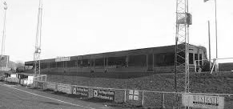
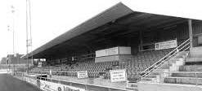
we had seven unbroken seasons of League meetings with some Associate Members Trophy matches thrown in. We also started to find some form against a team that was quite clearly struggling, winning nine of the fourteen and only losing two, both by the odd goal.

We won there 4-0 twice and 5-2 on another occasion but as the nineties ended you could see signs of improvement and they were denied promotion in 1998/99 by a point from Cheshunt, but were probably completely unaware of how Cheshunt got one of their points from us that season, as it was the famous “penalty incident” where we encroached on a penalty and Cheshunt were awarded a free kick instead of allowing us to retake!

They finally earned promotion in 2001 but we earned another four meetings as members of the Isthmian League Division One South following our own promotion in 2002. However, we lost all four without scoring and one particularly memorable 0-7 home defeat still rankles!

They have of course gone on to more success since then and were briefly members of the National Conference. This necessitated a virtual rebuild of their pretty ground and I was concerned that it would lose its character, but on a revisit a few years back I can confirm that it still looks great. All they need to do now is sort out the parking!

The old and the new at the Dripping Pan. Still a great venue though!

Epsom & Ewell F.C. Club History 1918 - 2014
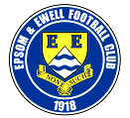
We were founded in March 1918 as Epsom Juniors Cricket Club and played throughout the summer. In the autumn, Epsom Juniors F.C. came into being and played a handful of games from what is now known as Alexandra Recreation Ground. Competitive football followed as we entered the Surrey Junior League in 1919, and became founder members of the Sutton & District League in 1920.

A change of name in July 1922 to Epsom Town F.C. heralded the start of a very successful era. By now resident at the Horton Hospital Sports Ground, we were unfortunate to lose 2-1 after extra time at Dorking F.C.’s Pixham Lane ground to Caterham Mental Hospital in a replay of the Surrey Junior Cup Final. However, we won three other trophies that season, the Leatherhead Hospital Shield, the Sutton Hospital Cup, and the Epsom Hospital Cup. In addition, we also won the Sutton & District League, and under the forward thinking of their visionary Chairman Hugh Bradley, took the step into Intermediate Football, where we won the Southern Suburban League without losing a match. Senior football was granted as we were unanimously accepted into the Surrey Senior League for 1924/25, where we finished third.

In September 1925, the club relocated to the old Ewell F.C. ground at West Street, which was purchased through the generosity of our future President Robert Bradshaw. In 1925/26 the Championship of the Surrey Senior League was attained, and the following season, we defeated Egham 1-0 at Egham in the League Charity Cup to complete a League and Cup “double”.

Election to the London League followed, and the title was claimed in the first attempt in 1927/28. Unfortunately, we were unable to repeat this, instead finishing runners-up in 1931/32, 1932/33, 1934/35, 1936/37 and 1937/38. Cup Honours were limited, although in 1929 Redhill defeated us 3-2 in front of 4,600 at Guildford in our first Surrey Senior Cup Final, having seen off Wimbledon 4-1 in the semi-final!

The thirties were a very successful era, and we won the Surrey Charity (Senior) Shield in 1933 with an impressive 5-0 win over Woking at Kingfield. However, the proudest moment of our pre-war history was an appearance in the First Round Proper of the F.A.Cup in 1933/34. Woking, Nunhead, Tooting & Mitcham, Beddington Corner, and Leytonstone were defeated, and a crowd of 9,485 at the Lea Bridge Speedway Stadium witnessed a 4-2 loss against the hosts Clapton Orient. At the end of that season we changed our name to Epsom F.C.

In 1939 a newly formed team, Epsom Town (no connection to the earlier name) shared the ground with Epsom F.C. However, this arrangement was suspended when war was declared, and we folded for the duration. In the meantime, Club Chairman Charles Pettett threw in his lot with Epsom Town in an attempt to boost morale by keeping the football flag flying. It was successful, as that club competed continuously throughout the war years, winning the Surrey Combination in 1939/40, and reaching the Surrey Senior Cup Final in 1944, losing 3-1 to Tooting & Mitcham, at Sandy Lane. After the war, Epsom F.C. restarted, continuing in the London League and reclaimed West Street. Temporary homes were found for Epsom Town while they competed for a season in the newly created Corinthian League, but disbanded in 1946.

In 1949 we entered the Corinthian League ourselves, where in 1952 we reached the League Memorial Shield Final in 1952, going down 2-1 to Champions Hounslow at Eastbourne after leading at half-time. Things improved further with the signing of the former English Amateur International Pat Lynch from Hendon, finishing third in 1952/53, while in 1954 we reached the Surrey Senior Cup Final for the second time in our history, losing unluckily 2-0 to Corinthian Casuals in front of 6,159 at Selhurst Park. In 1955 we won the Surrey Senior Shield with a 1-0 win over Carshalton Athletic at West Street.

We appointed our first ever Manager, Kingstonian legend Doug Whitehead in 1955 and the Corinthian League double was almost achieved in 1956/57, but two losses in the final week, along with a 2-0 defeat in the Cup Final to Maidenhead United at Dorking ensured that we ended with neither, finishing fourth. However in 1960, we finally raised the Shield with a 2-0 revenge win over Maidenhead at Vale Farm, home of Wembley F.C.

In 1960 we changed our name once again to Epsom & Ewell F.C. This was not because of any merger with Ewell & Stoneleigh as is often quoted, but was an attempt to increase support across the whole of the Borough. In 1963 the Corinthian League merged with the Athenian and Delphian Leagues, and we were placed in Division One of the new structure, but the sixties were full of poor results and we were relegated in 1965.

Despite a string of managers, most notably ex-Leyton Orient winger Jimmy Smith, and Tony Williams, now famous for his creation of the F.A. Yearbooks, our fortunes did not improve significantly and further relegations were avoided in the early seventies by the benefit of re-election. However in 1973, despite “improving” to finish second from bottom, the Athenian League ran out of patience and cut us loose. This was unfortunate timing as

we had just cleared all of our debts, and in addition to a virtually new Committee, former Fulham player Pat O’Connell had taken over as Manager.

The Surrey Senior League took us in at the last minute, and the new squad, including young striker Tommy Tuite, won the League Cup, and the following season, 1974/75 achieved a second Surrey Senior League “double”. However, the season would always be remembered for reaching the Final of the inaugural F.A. Vase, where 9,500 saw the Blues edged out 2-1 by Hoddesdon Town at Wembley Stadium. The Athenian League welcomed us back, and promotion to the top flight was achieved in that first season. In 1976/77 we reached the Athenian League Cup Final, losing 1-0 at Chalfont St Peter.

For 1977/78 many clubs were invited to join the expanding Isthmian League, and we were placed in the new Division Two. Our first match under floodlights took place against Met Police, and the title was clinched the following April. In 1979/80 we won the Southern Combination Cup 7-2 over Hampton on their own pitch, where the opposition were blitzed by five goals from Tuite. The following season a new clubhouse opened at West Street, and we finally won the Surrey Senior Cup, defeating Woking 2-1 at Tooting & Mitcham, although we just missed out on promotion. In 1983/84 we clinched a spot in the Premier Division as runners-up, although this time we missed out in the Surrey Senior Cup Final, defeated 4-0 by Sutton United at Imber Court.

With Adrian Hill as Manager since 1982, we survived comfortably in our first season at the new level, but Hill’s departure to Croydon in 1985 started a decline. Much of the squad left with Hill, and new Manager Alan Webb had too much to do. We were relegated in 1986, and following Webb’s departure soon after, Player / Manager Ricky Kidd nearly but not quite saved us from our second straight relegation. Adrian Hill replaced Kidd for a second spell at the helm in 1990, but we were placed in the new Division Three in 1991 in league reorganisation following a finish one position below the required half way mark.

In 1993 a large chapter in our history ended as we left West Street and moved in as tenants of Banstead Athletic. The decade was largely one of frustration, although we did reach the Final of the Associate Members Trophy, losing 2-0 to Bedford Town at Hendon’s old Claremont Road ground.

In 2002 Adrian Hill took us back up to Division 1 South, where we topped the table for a month, eventually finishing 9th, but Hill’s retirement at the end of the season led to relegation a year later and in 2006 we were transferred into the Combined Counties League Premier Division. In October 2006 Lyndon Buckwell, a former player became our new Manager, and in his first full season (2007/08) we were back in the top ten. In 2008/09 we exceeded this achievement and finished in fourth place after heading the table for a few months. In 2009/10 the club recovered from a slow start to finish fifth and also reached the last 32 of the F.A.Vase for the first time in 21 years, bowing out 3-2 in Northamptonshire to Long Buckby. In April of 2010 we terminated our seventeen-year ground sharing agreement with Banstead Athletic and spent two unspectacular seasons at Merstham F.C. before relocating to High Road, home of Chipstead F.C. for the 2012/13 season.

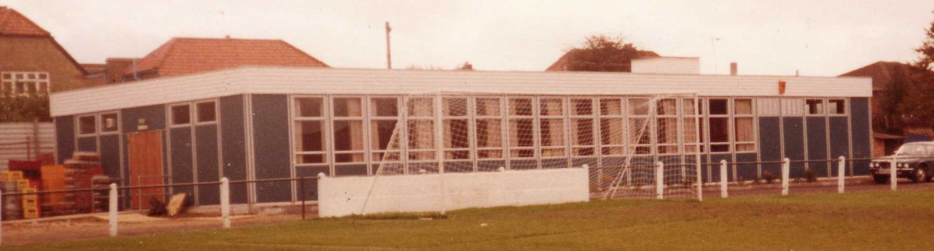
The season brought significant playing success as a slow start was followed by a spectacular run of form, including a club record 12 straight League wins, which put us at the top of the table for over a month before a tough run in resulted in a final position of fifth. However, any disappointment there was tempered by the club’s first silverware since 1981 when we defeated South Park 3-0 at Farnborough to win the Combined Counties League Cup. Lyndon also marked 300 games in charge of the club in early 2013. On a sadder note, 2012/13 also marked one thousand games and twenty seasons since we left West Street.

We carried our fine form into 2013/14 and led the league with eight straight wins but couldn’t hold on and had to settle for third place, our highest league finish since 1984, and we continue at High Road for 2014/15.

Meanwhile, the search continues for a new ground back in the Borough…..

Ice Bucket Challenge
Many of you will be aware of the Ice Bucket Challenges that are happening around the globe, but don’t know much about Motor Neuron Disease even though it kills three people a day in the UK. Here’s a quick recap about a horrible disease that has no known cure. There are four main types:

1) Amyotrophic Lateral Sclerosis (ALS). This is the most common type and is characterised by muscle weakness and stiffness, over-active reflexes and, in some cases, rapidly changing emotions. Initially the limbs cease to work properly. The muscles of speech, swallowing and breathing are usually also later affected. This type is also known as Lou Gehrig’s disease; he was an extremely successful American Baseball player, holding many records in the game and was also durable, holding the record for most consecutive games played, and not missing a single game for an incredible fourteen consecutive years; tallying 2,130 in a row. In fact, the record run only ended following his diagnosis and it killed him two years later in 1941 at the tragically young age of 37.

2) Progressive bulbar palsy (PBP). Mixed bulbar palsy and pseudo-bulbar palsy are forms of progressive bulbar palsy that involve the muscles of speech and swallowing. The nerves that control these functions are located in the bulb (the lower part of the brain), hence the term bulbar palsy (paralysis). The limb muscles may also later be affected. This affects about a quarter of people diagnosed, and involves both the upper and lower motor neurons.

3) Progressive muscular atrophy (PMA). This affects only a small proportion of people, mainly causing damage to the lower motor neurons. Early symptoms may be noticed as weakness or clumsiness of the hand. Characterised by a slower rate of progression and longer survival compared to ALS and PBP types.

4) Primary lateral sclerosis (PLS). This is a rare form involving the upper motor neurons only.

It is the commonest of the four types (ALS) which also killed the famous actor David Niven, the famous Celtic legend Jimmy Johnstone, and the Chinese leader Chairman Mao that is gaining the real publicity. I think the challenge is a great way to publicise a deserving cause. At least after reading this, you can now tell people that you know what it’s all about, even if the idea of an ice bath is not for you!
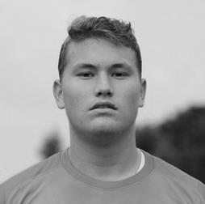

At our club, we have three people who have completed the challenge so far; Michael Eacott, Sam Currie and myself and it is hoped that more will follow soon. The challenges can be seen from our website: www.eefconline.co.uk so why not have a look in?

EL Records Premier Challenge Cup
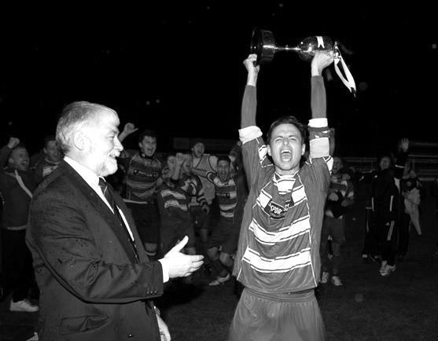
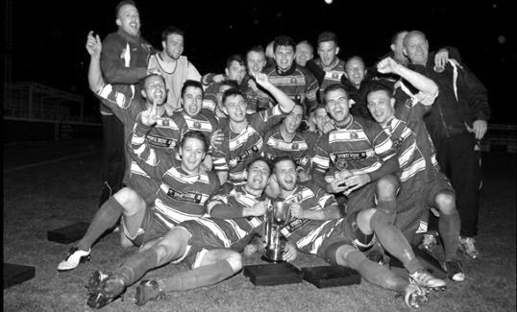
First Round
Raynes Park Vale | 16/9 | Spelthorne Sports
Bedfont Sports | 16/9 | Staines Lammas
Chertsey Town | 1/10 | Hartley Wintney
Frimley Green | 16/9 | AFC Croydon Athletic
Sandhurst Town | 16/9 | Horley Town
Second Round
Alton Town | 14/10 | Farnham Town
Eversley & California | 21/10 | Ash United
Cobham | 14/10 | Sandhurst Town /  Horley Town
Frimley Green /  AFC Croydon Athletic | 14/10 or 15/10 | Raynes Park Vale /  Spelthorne Sports
Bedfont Sports /  Staines Lammas | 14/10 | Cove
Westfield | 14/10 | Farleigh Rovers
Ashford Town (Mx) | 30/9 | CB Hounslow United
Colliers Wood United | 1/10 | Bedfont & Feltham
Worcester Park | V | Chessington & Hook United
Sheerwater | 11/10 | Mole Valley SCR
Badshot Lea | 14/10 | Dorking
Chertsey Town /  Hartley Wintney | 14/10 or 15/10 | Windsor
Epsom & Ewell | 14/10 | Knaphill
Camberley Town | 14/10 | Molesey
Epsom Athletic | 15/10 | Banstead Athletic
Hanworth Villa | 14/10 | Guildford City
Surrey Senior Cup
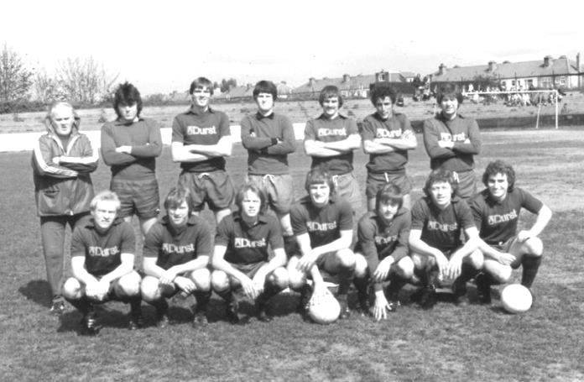
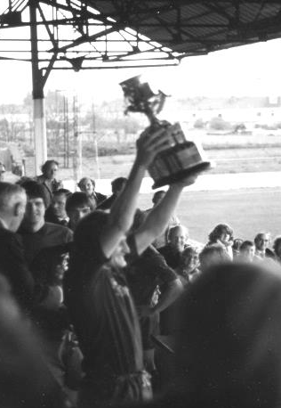
First Round
Carshalton Athletic | 21/10 | Egham Town
Croydon | V | Colliers Wood United
Merstham | V | Whyteleafe
Raynes Park Vale | V | Chertsey Town
South Park | V | Guildford City
Second Round
Lingfield | V | Westfield
Redhill | V | Raynes Park Vale /  Chertsey Town
AFC Wimbledon | V | Chipstead
Godalming Town | V | Mole Valley SCR
Knaphill | V | Croydon /  Colliers Wood United
Metropolitan Police | V | Walton & Hersham
Epsom & Ewell | V | Camberley Town
Leatherhead | V | Farnham Town
Merstham / Whyteleafe | V | Beckenham Town
Molesey | V | Carshalton Athletic /  Egham Town
South Park / Guildford City | V | Sutton United
Walton Casuals | V | Corinthian Casuals
Badshot Lea | V | Kingstonian
Dorking Wanderers | V | Frimley Green
Tooting & Mitcham United | V | Horley Town
Woking | V | Ashford Town (Mx)
F.A. Vase
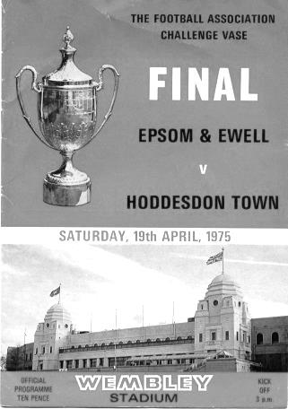
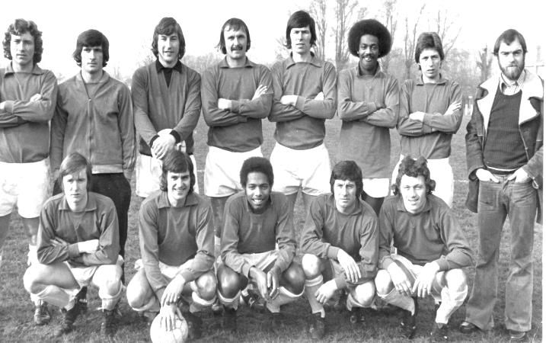
First Qualifying Round – 6th September
Cove | 2-3 | Wootton Bassett Town
Hartley Wintney | 3-2 | Holyport
Holmesdale | 4-5+ | Colliers Wood United
Horley Town | 3-2 | Sevenoaks Town
Lancing | 4-1 | Mole Valley SCR
Langford | 2-2+ | Spelthorne Sports
Raynes Park Vale | 2-1 | Crowborough Athletic
Windsor | 3-0 | Shrivenham
Woodley Town | 3-0 | Badshot Lea
First Qualifying Round replay – 9th September
Spelthorne Sports | 4-1 | Langford
Second Qualifying Round – 4th October
Colliers Wood United | V | Shoreham
Cray Valley (PM) | V | Horley Town
Farnham Town | V | Milton United
Flackwell Heath | V | Frimley Green
Highworth Town | V | Hartley Wintney
Spelthorne Sports | V | Risborough Rangers
Molesey | V | Greenwich Borough
Raynes Park Vale | V | Epsom Athletic
Rothwell Corinthians | V | Bedfont Sports
Windsor | V | Binfield
Woodley Town | V | Knaphill
Exempted Clubs
Ashford Town (Mx) – 1st Round |  | Guildford City – 1st Round
Camberley Town – 1st Round |  | Westfield – 1st Round
Chertsey Town – 1st Round
Epsom & Ewell – 1st Round |  | Hanworth Villa – 2nd Round

Player Sponsorship
Here is the opening list of the season showing all of the players and Management available for sponsorship. Sponsorship costs £40 so if you want to help the club, the player and get your name in the programme for the season, just let us know.

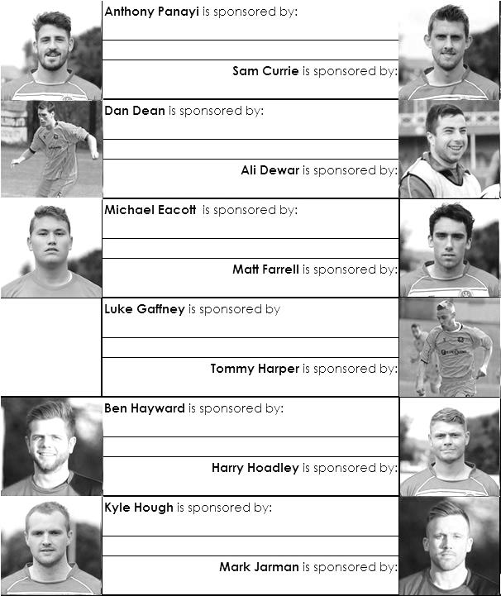

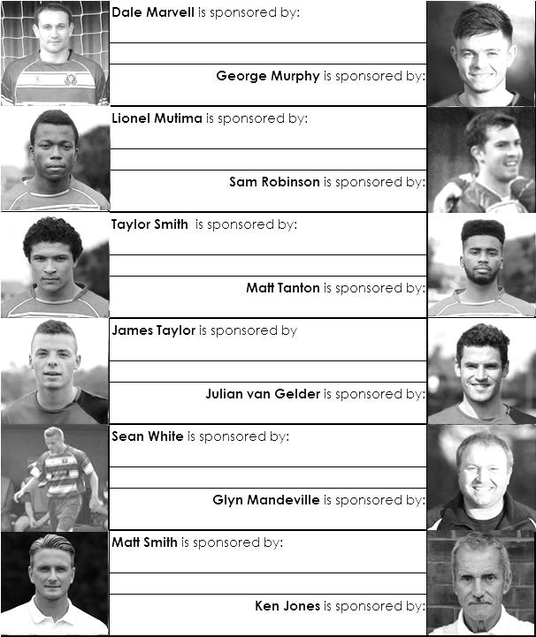

We are not fussy, we’ll take cash or a cheque! Just bring your money, cash or cheque to a Committee member.

Our New Website
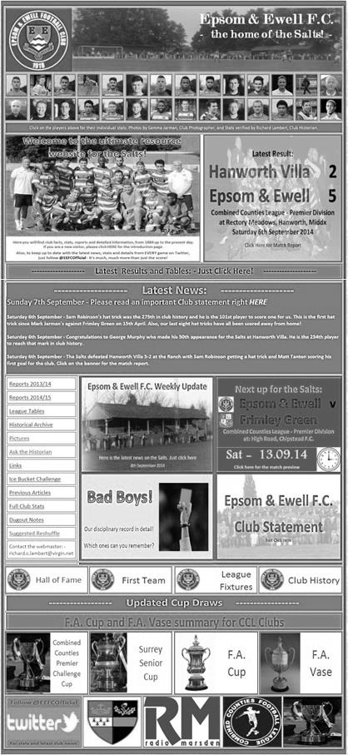
Have you seen our new website?

For those who are unaware, the new website, constructed by Media Officer Richard Lambert and celebrating its first birthday this week, contains everything you could possibly want to know about the club, and an enormous amount you probably weren’t that bothered about!

Our previous site will still exist, but will become a photo archive only, housing the enormous wealth of pictures provided by Gemma Jarman, our Club photographer. In addition, there are over a thousand historical images of teams, players, action shots and programme covers.

As you can tell from the screenshot of our front page, there is a substantial amount of information all available at the touch of a button, which is also very useful if you own one of those new touchscreen personal computers that are becoming more and more popular these days.

If you are a supporter, please pass the address on to anyone you know that has ever expressed an interest in the club, especially those who don’t visit any more. You never know, some of them might be inspired to come along too, and bring their friends etc.

http://www.eefconline.co.uk/

Photos of the Week
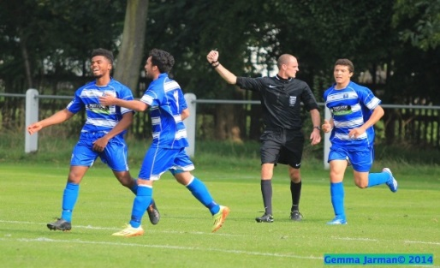
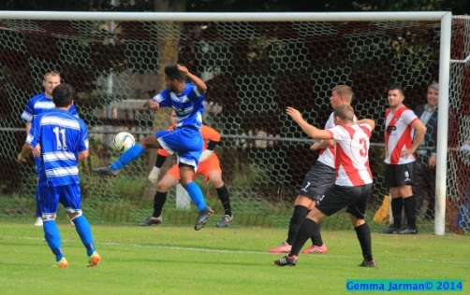
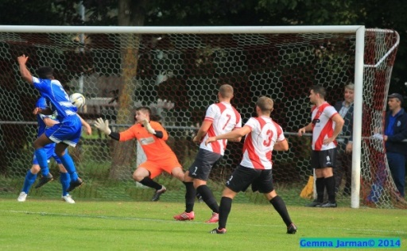
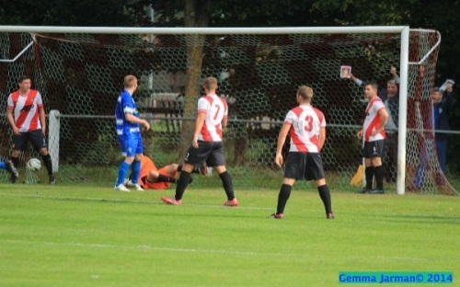

The photos of the week have returned to the programme. This week we cover our 5-2 win at Hanworth Villa, and in particular, a spectacular volleyed goal from Matt Tanton. It was so good, even the referee appears to be celebrating! As is so often the case, Gemma Jarman caught it perfectly, so here it is.
Many more of Gemma’s photos from almost every Salts game played in the last five years are available on our website: Why not have a look?

George Murphy – 50 Appearances
Congratulations go to George Murphy who made his 50th appearance for the club in our 5-2 win at Hanworth Villa on Saturday 6th September.

He joined us from Chipstead and made his debut in the home League match with Guernsey in March 2013. Ironically, that result also finished 5-2, just not in our favour!

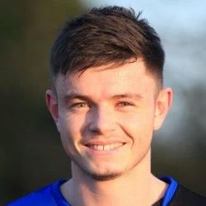
George has become the 254th person to reach this figure, which might sound a lot, but when you realise that 1,526 players have represented the team over ninety years of existence in Senior football, you realise that it is quite an achievement.

Here’s hoping for many more appearances for the Salts.

Combined Counties League – Premier Division
Saturday, 13th September 2014 - Kick-off 3.00 p.m.
Epsom and Ewell  (Royal Blue & White hoops) | V |  | Frimley Green  (Red, Red, Black)
 | NUMBERS
Michael Eacott |  |  | Jamie Cunningham
James Taylor |  |  | Andrew Grace
Matt Tanton |  |  | Paul Andrews
© Anthony Panayi |  |  | Dale Webb
Dan Dean |  |  | Darryl Bloxham
Harry Hoadley |  |  | Lee Page
Carl Downs |  |  | Brad Cann
Dale Marvell |  |  | Cameron Balckie
Taylor Smith |  |  | Nick Thumwood
Kyle Hough |  |  | Bobby Hogg
Sam Robinson |  |  | Stephen Taylor
Oshane Brown |  |  | Matthew Griffiths
Matt Farrell |  |  | Matthew Stamp
Lionel Mutima |  |  | Dan Simmonds
Luke Gaffney |  |  | Matt Baker
Richard Lediju |  |  | Anton Murphy
George Murphy |  |  | Luke Whiddett
Ali Dewar |  |  | Edward Cardona
Sean White |  |  | Louis Hibbert
Julian van Gelder |  |  | Michael Smith
Lyndon Buckwell | MANAGER |  | Derren Martin
Glyn Mandeville | ASSISTANT |  | Mick Wollen
 | ASSISTANT |  | Steve Lynch
Tony Coombe | CHIEF SCOUT
Matt Smith | COACH |  | Scott Tarr
Ken Jones | PHYSIO
REFEREE: D.Bandara (Epsom)
ASSISTANTS: K.Corrick (Oxted), M.Dilawari (Battersea)
Today’s Match and Match Ball are sponsored
by Dave Gaffney and friends

OUR NEXT VISITORS TO HIGH ROAD

Guildford City

Tuesday 30th September 2014 - Kick-off 7.45 p.m.
Combined Counties League – Premier Division

